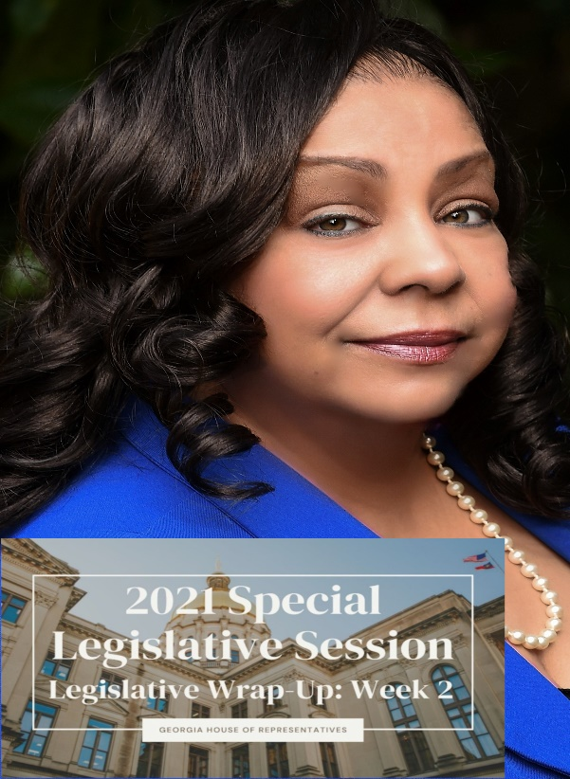
As an entertainment Publicist, and freshman member of the Georgia General Assembly, ‘There’ll Come a Time’, a song published by one of the most sampled artist in the US, encircled my every thought on Wednesday, November 10th when the house legislative body took to task, a vote mostly along party lines, known as HB 1EX— legislation related to the redistricting process of maps— drawn by the majority members of the Republican-led Georgia House of Representatives which adopted new boundaries for the 180 House districts.
After countless weeks of meetings and debates, the House approved a map proposed by GOP leadership 99-79. As I watched the process unfold, it was clear that the House Dem’s, who voted against the proposed map, had begun the process of ACCEPTING that there was no path in which to win the vote and thus, ‘There’ll Come a Time’ kept creeping in and re-winding in my head as we cast our ballads, To my chagrin, a few incumbents were pitted against one another, and in the end, we know for sure there will be a loser and there will be a winner in the next election cycle so we will be losing a House member and I shudder the thought.
The Georgia House of Representatives reconvened for the second week of the 2021 special legislative session on Monday, November 8, 2021.
The General Assembly redraws Georgia’s legislative and congressional district lines each decade to accommodate changes in population reflected in the U.S. Census. The crafted map not only keeps House districts as close to equal in population as possible — the goal being 59,511 residents. The map also creates 49 majority Black House districts, an increase of one district over the current House map lawmakers adopted in 2011, as well as 27 “minority-opportunity” districts where minority candidates should be competitive
To begin the week, the House Legislative & Congressional Reapportionment Committee held two additional hearings to receive public commentary on the proposed House district map. This bill then went to the House Rules Committee, where it was scheduled for a vote on the House floor, and HB 1EX was passed on Wednesday, November 10. This bill will now undergo the same process in the Senate.
You can view a copy of this map which will serve as the new district 91 REP beginning in 2022 which includes updated boundary lines for House District 91, here.
Likewise, our colleagues in the state Senate continued their work this week on the updated map for Georgia’s 56 state Senate districts, or SB 1EX and is expected to come before the House of Representatives for a vote next week. Furthermore, the Senate will also begin reviewing the House district map. You can find a copy of the proposed Senate map here.
In addition, we observed Veteran’s Day on Thursday, and therefore spent four days meeting on the House floor and in our committees.
My colleagues and I also gathered for a special Veteran’s Day ceremony at the State Capitol this week. State leaders, including Governor Brian Kemp and Speaker David Ralston, were joined by several veterans who shared their remarks and reminded us of the true inspiration behind this federal holiday. Many of my own House colleagues have served in the U.S. Armed Forces, and it was an honor to join them as we remembered those who dedicated their lives to protecting and defending the constitution of the United States of America.
The redistricting ‘process’ has taken up most of the summer, all of the fall, and if we are lucky, we'll be out in enough time to enjoy Thanksgiving dinner at home with our families.

You can find information about the state’s redistricting process on the nonpartisan Legislative and Congressional Reapportionment Office’s webpage. This webpage includes all of the General Assembly’s current and proposed maps, an online portal to submit and read public comments about the process, an informational video about the redistricting process and many other helpful resources.

While much of my attention is currently focused on redistricting, I am also using this time to prepare for the 2022 regular legislative session, which will convene in January. I encourage you to contact me regarding the redistricting process or any other topics that are important to you and your community.
You may reach my Capitol office at 404-656-0220 or via e-mail: angela.moore@house.ga.gov.
As always, thank you for allowing me to serve as your state representative for House District 90.

